AFWA Dues Renewal FAQ
There are lots of new programs, products and services with more to come. Check out our newly updated website at afwa.org
With dues renewal comes lots of questions so we thought we would try to answer some of those in this FAQ.

What do I get for my dues and why should I renew? 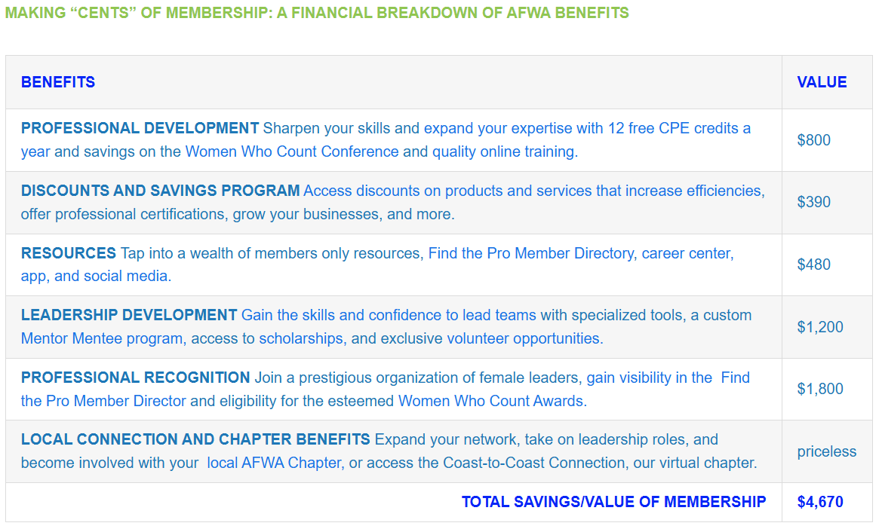

What date must my dues be paid by?
To receive the discounted amount, you must make payment by May 31. Payments after that date will be the full dues amount and must be paid by June 30.
 | Regular/Affiliate | Associate | Student | Retired
If paid by May 31 | $215 | $105 | $45 | $49
After May 31 | $225 | $110 | $45 | $49

How do I renew?
You can pay online or mail a check to AFWA Headquarters at
AFWA
2365 Harrodsburg Road, Suite A325
Lexington, KY 40504

To pay online:
- Log into the member portal
- Go to My Membership
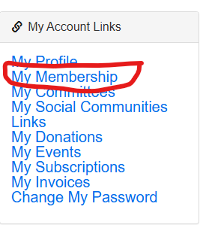
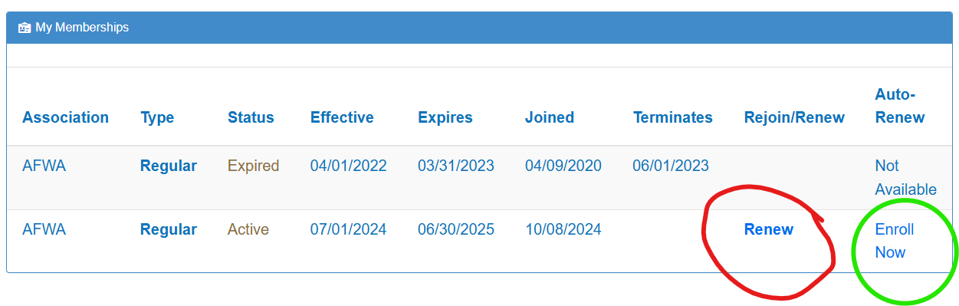
- Select Renew

- Update Your Contact information if needed. Then select update at the bottom of the page
- Verify Your renewal of membership and your chapter membership and then select renew. You can add your payment information in at that time.
  - If you would like to enroll in auto renew (please see step #3 green circle) select Enroll Now
  - Select “Yes I want to auto renew” then next button
  - Enter your payment information then Save and Proceed.
What if I am already on auto renew?
If you are on auto renew, you will automatically receive the discounted dues amount and your payment will be processed on June 15, 2025. Please go into your membership record and make sure your credit card is up to date. In the event, your credit card cannot be processed, you will be responsible for the full dues amount. After 2 failed attempts to process your dues on auto renew, you will be removed from the auto renew process and you will receive a hard invoice in the mail.
My company pays my dues, so how do I get them an invoice?
- Log into the member portal and follow steps
- Select My invoices
- Select the dues invoice
- Click on more details
- Click on Print Invoice on the top right corner.
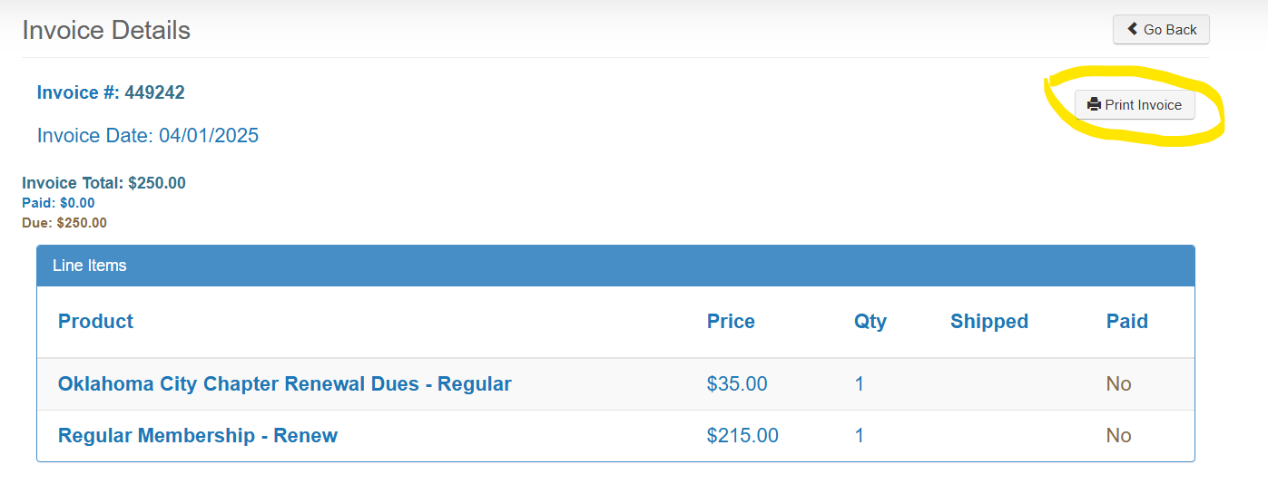
I’m a lifetime member; how do I pay my local chapter dues?
As a lifetime member you must go into the member portal to pay your invoice. Follow steps 1-5 on “how do I renew”.
I’m a lifetime member, how do I become a Sustaining Lifetime Member?
- Follow the steps above for renewal and purchase through the store.
How do I renew if I am a Sustaining Lifetime Member?
- Log into the member portal
- Scroll to the bottom and select “Membership Toolkit”
- Select “Online Store” from the top menu bar



- Select the second page of items
- Select Sustaining Lifetime Member Subscription
You will only see this item if you are a Lifetime Member
- Go to Cart
- Enter payment information
- Complete the sale.
What happens if my dues are not paid by July 1?
If your membership is not paid by July 1, your membership will be suspended, and you will have until September 1 to renew your membership. After that date your membership will be terminated, and you will need to rejoin as a new member.
How do I reset my password to get into the membership portal?
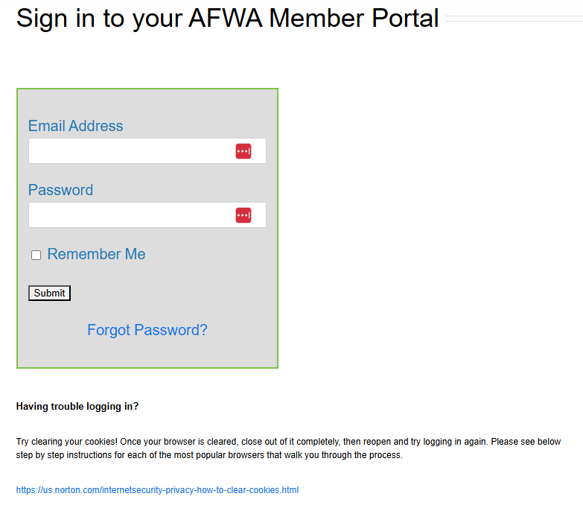

If you are still having difficulty logging in, please contact member services at shared@afwa.org.

