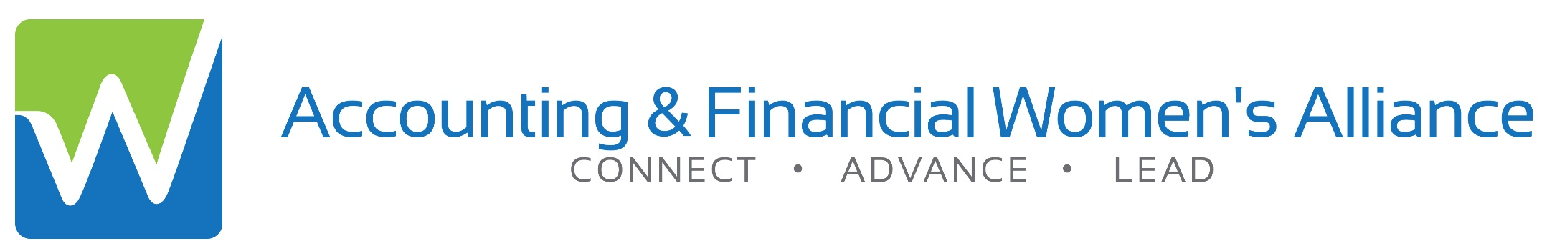**Book club will run from September 6, 2018 through October 18, 2018**

From Aug. 13th – Sept. 5th Purchase the book [here](https://www.amazon.com/How-Remarkable-Women-Lead-Breakthrough/dp/030746170X/ref=sr_1_1?ie=UTF8&qid=1533083773&sr=8-1&keywords=how+remarkable+women+lead)

To register click [here](https://www.afwa.org/book-club/) – Book club is limited to 30 people

No. 1 Ladies Book Club